**Q1 Get an overview of MCSdb from the Home page**

**Overview:**

The current version of MCSdb documents about 6,600 manually curated MCS protein entries with experimental evidence, refers to more than 6,000 proteins, 15 organelles and 29 MCSs across 5 species. And MCSdb also collected over 170 protein complexes reside in different MCSs with experimental evidence. In summary, MCSdb provides a convenient and user-friendly interface for querying, browsing and visualizing detailed information about these MCS proteins, and will be of help in elucidating the functions and mechanisms of action of MCS proteins and promoting inter-organelle communication research.

The homepage is displayed in the following Fig 1-1.

Fig 1-1

1. Main functions of the database are provided in menu bar form (boxed in red).
2. Introduction and overview for MCSdb.
3. Quick search for users.

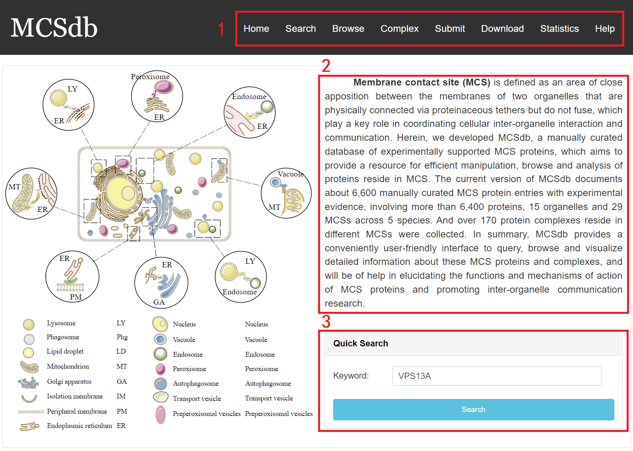

**Fig 1-1. homepage**

**Q2 How to implement Exact, Batch and Blast search in Search page?**

The search page is displayed in Fig 2-1, 2-2 and 2-3:

**Exact search:**

1. Select exact search.
2. Select type of input keyword: three choices are provided (Protein Symbol/Uniprot ID/Entrez ID).
3. Input a keyword corresponding to selected type.
4. Select the species to filter the search (5 species: Human, Mouse, Rat, Yeast and Arabidopsis thaliana).
5. Select detected method to filter the search (3 methods: Low throughput experimental methods, Proximity Labeling Techniques and Mass-spectrometric techniques).

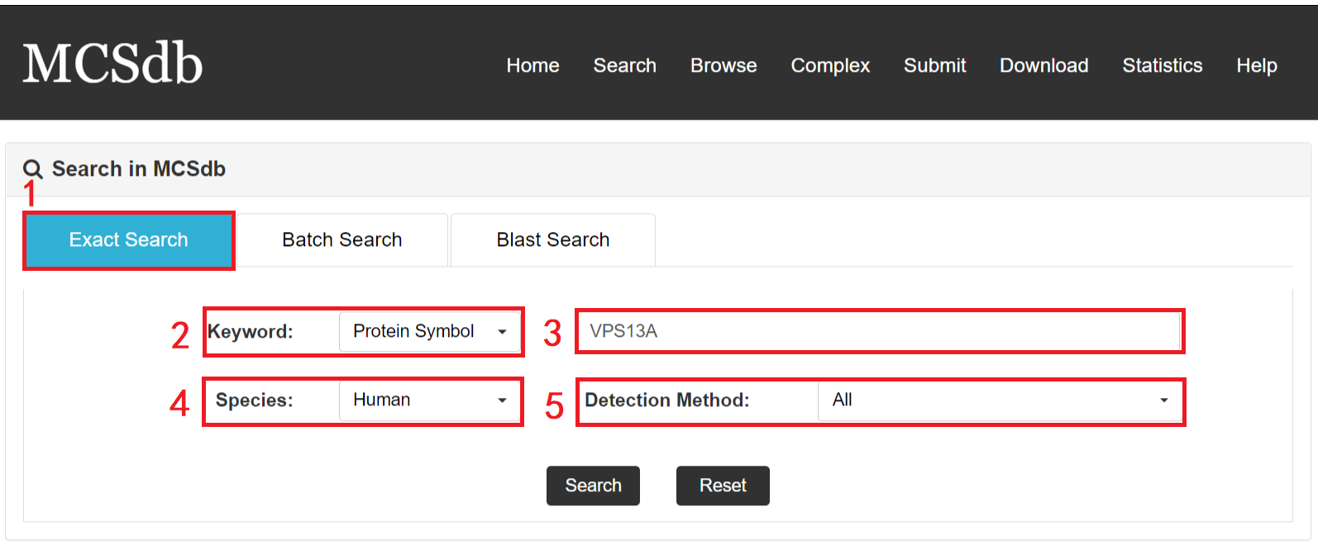

**Fig 2-1. Exact Search page**

**Batch search:**

1. Select batch search.
2. Select type of input keyword: three choices are provided (Protein Symbol/Uniprot ID/Entrez ID).
3. Input list of keywords corresponding to selected type.
4. Select the species to filter the search (5 species: Human, Mouse, Rat, Yeast and Arabidopsis thaliana).
5. Select detected method to filter the search (3 methods: Low throughput experimental methods, Proximity Labeling Techniques and Mass-spectrometric techniques).

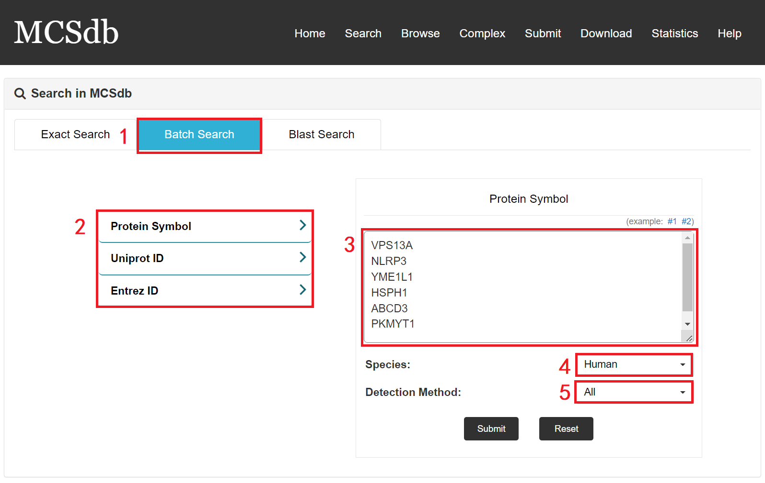

**Fig 2-2. Batch Search page**

**Blast search:**

1. Select Blast search.
2. Select type of input keyword: three choices are provided (Protein Symbol/Uniprot ID/Entrez ID).
3. Enter a sequence to do search.

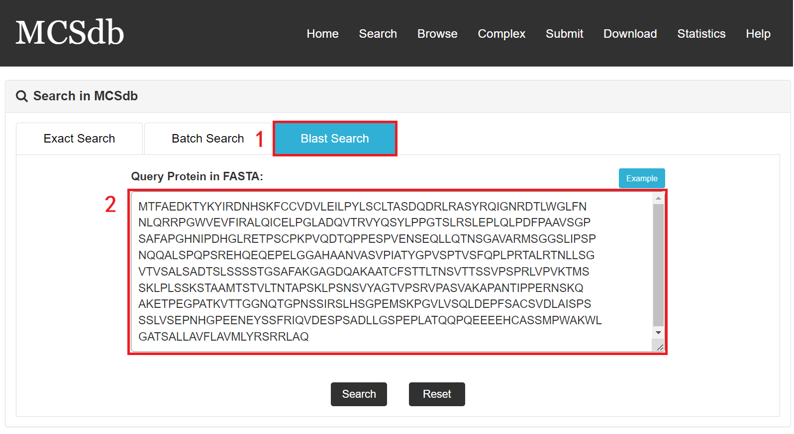

**Fig 2-3. Blast Search page**

**Q3 How to read the search results?**

**Result page of Exact search and Batch search:**

For the result page of Exact search and Batch search, all entries are listed with basic information including gene ID, Uniprot ID, symbol, Species, MCS, Experimental method.

Fig 3-1

1. Search keyword from the result table.
2. The result table (including gene ID, Uniprot ID, symbol, Species, MCS, Experimental method).
3. Click to link to Detail page.

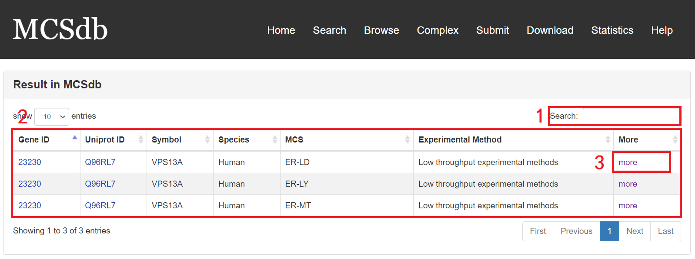

**Fig 3-1. Result page of Exact search and Batch search**

**Result page of Blast search:**

For the result page of Blast search, all entries are listed with basic information including gene ID, Uniprot ID, symbol, Species, MCS, Experimental method, start and end of the matched sequence of documented proteins and Bit-score.

1. Search keyword from the result table.
2. The result table (including gene ID, Uniprot ID, symbol, Species, MCS, Experimental method).
3. Click to link to Detail page.

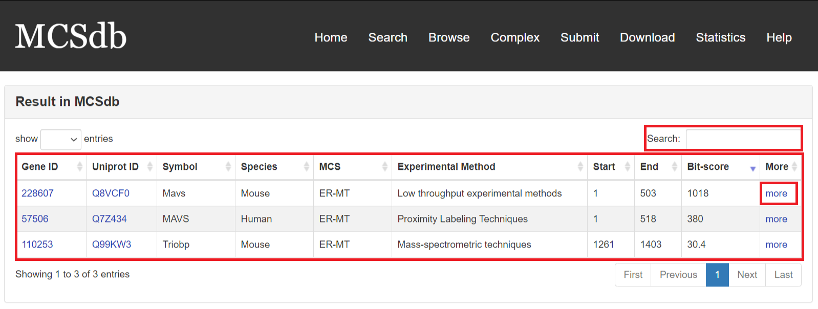

**Fig 3-2. Result page of Blast search**

.

**Q4 How to read Detail page?**

In the Detail page, you can get the detail information of the MCS proteins including “Basic Information”, “Complex information”, “The expression of protein across different tissues”, “Homology Information (EggNOG, HOGENOM, OrthoDB, TreeFam and GeneTree databases)” and “References”.

Fig 4-1

1. Basic Information: including Symbol, Species, Gene ID, Uniprot ID, Membrane Contact Site, Location (from literature), Cell line/Tissue, Experimental Method and protein sequence and protein sequence.
2. Complex information: including Complex ID, Subunit of complex, Subcellular location, Species and hyperlink to the detail page of complex.
3. The expression of MCS protein across different tissues.
4. Homology Information: including ortholog ID from EggNOG, HOGENOM, OrthoDB, TreeFam and GeneTree databases.
5. References: the PMID and description from literatures related to the MCS proteins.

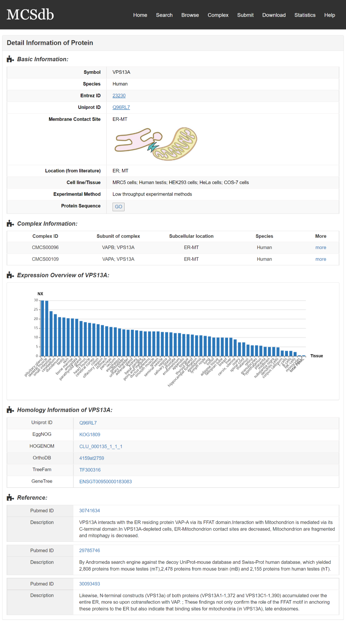

**Fig 4-1. Detail page**

**Q5 How to use Browse page?**

The MCS protein list was presented in the Browse page, Users can browse all the proteins by three filter ways: by species, by MCS and by detected method.

Fig 5-1

1. Filter by species (5 species: Human, Mouse, Rat, Yeast and Arabidopsis thaliana).
2. Filter by MCS (29 type of MCSs).
3. Filter by detected method (3 methods: Low throughput experimental methods, Proximity Labeling Techniques and Mass-spectrometric techniques).
4. The result table.

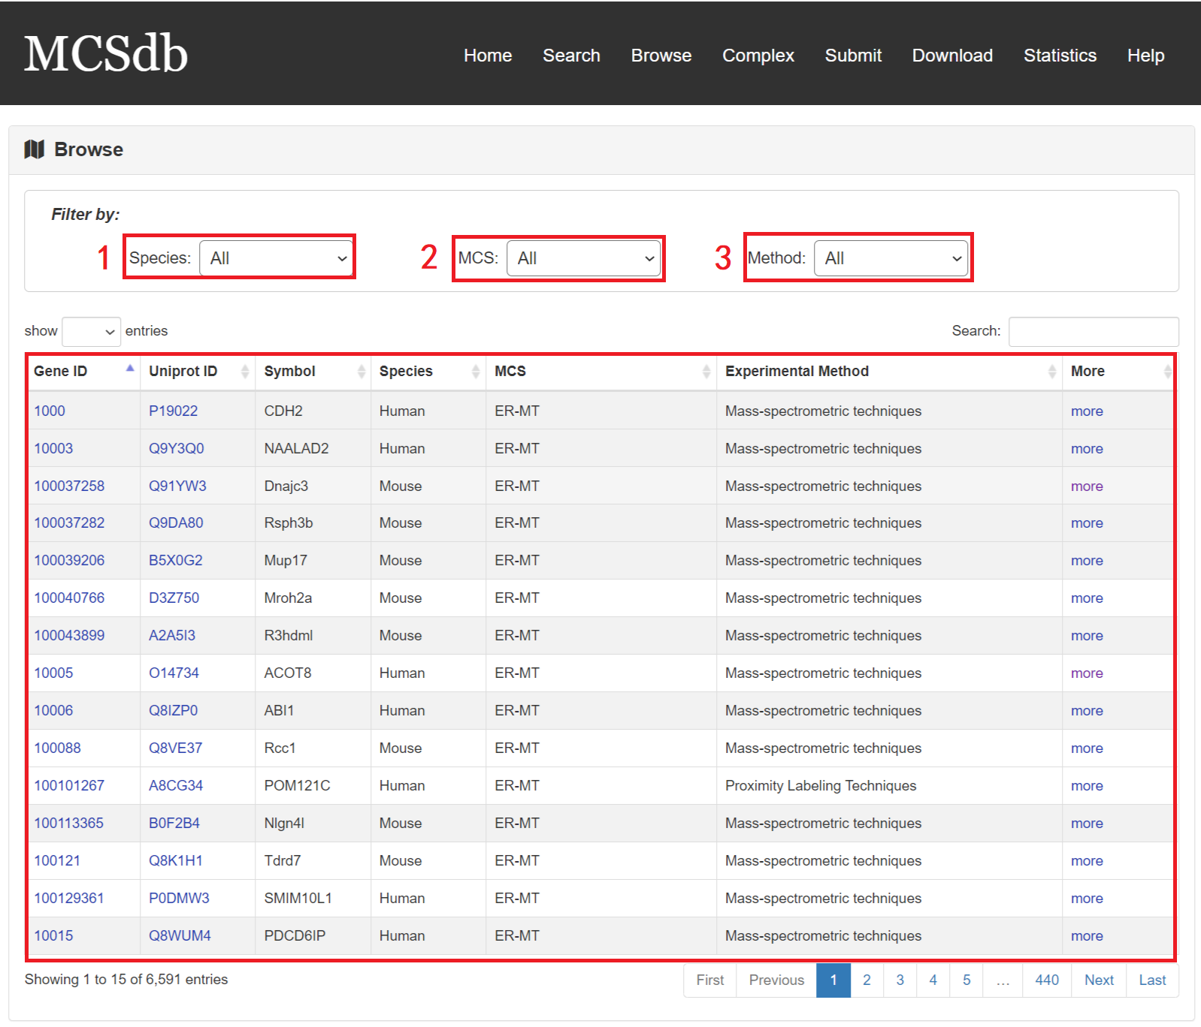

**Fig 5-1. Browse page**

**Q6 How to use Complex page?**

To help the users to browse the complexes reside in MCS, MCSdb provides an independent webpage to query, browse and visualize detailed information about the 174 MCS complexes.

Fig 6-1

1. Search keyword form the complex table.
2. Complex table (complex ID, subunit number, complex name, species and MCS).
3. Click to link to Detail page.

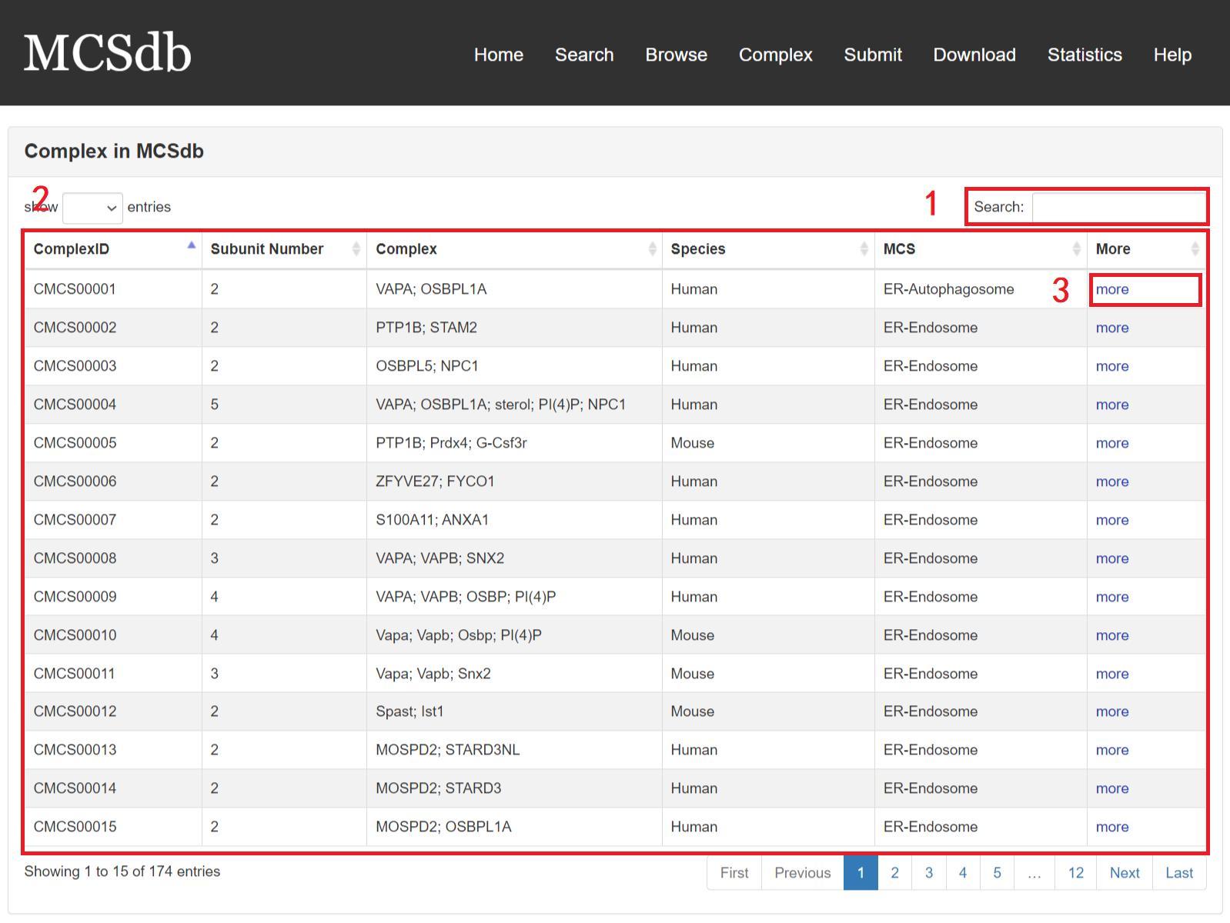

**Fig 6-1 Complex page**

In the Detail page of complex, you can get the detail information of the MCS complex including “Basic Information”, “Subunit information” and “References”.

Fig 6-2

1. Basic Information: including Complex ID, Complex name, subunit number, Membrane Contact Site and species.
2. Subunit information: including subunit symbol, Uniprot ID, Subcellular location and hyperlink to the detail page of complex.
3. References: the PMID and description from literatures related to the MCS complex.

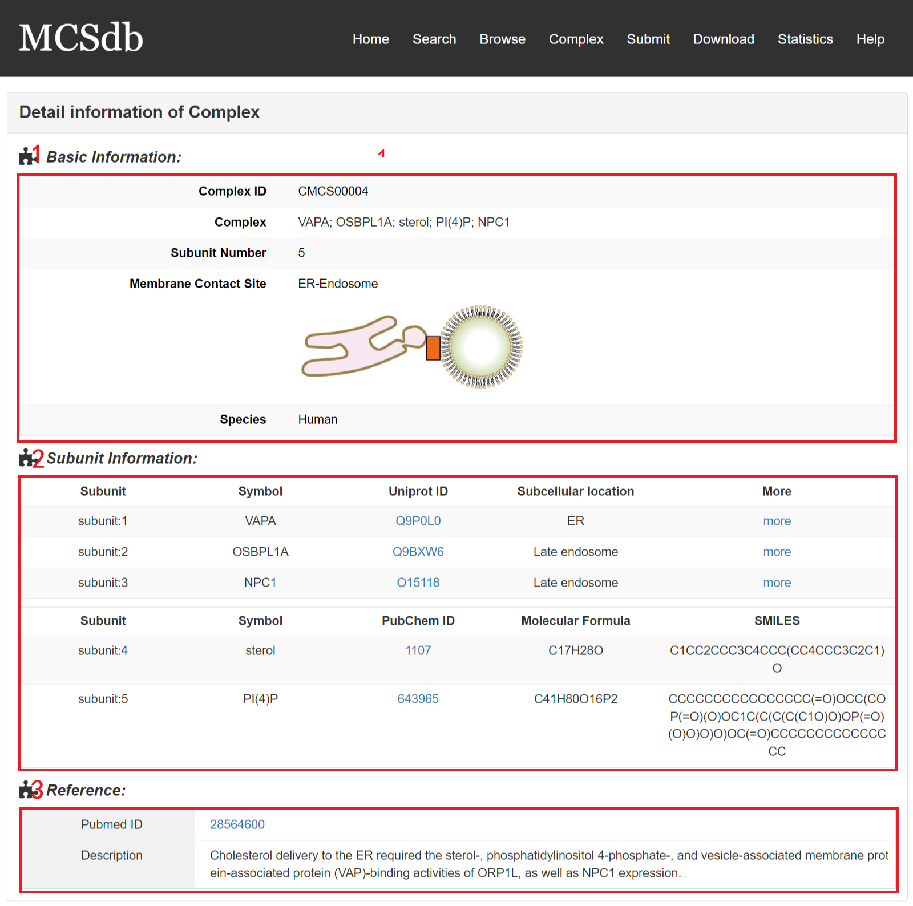

**Fig 6-2 Detail page of complex**

**Q7 How to download the MCS protein and complex data?**

MCSdb provide the download page for users. You can download all the proteins and complexes data in the download page.

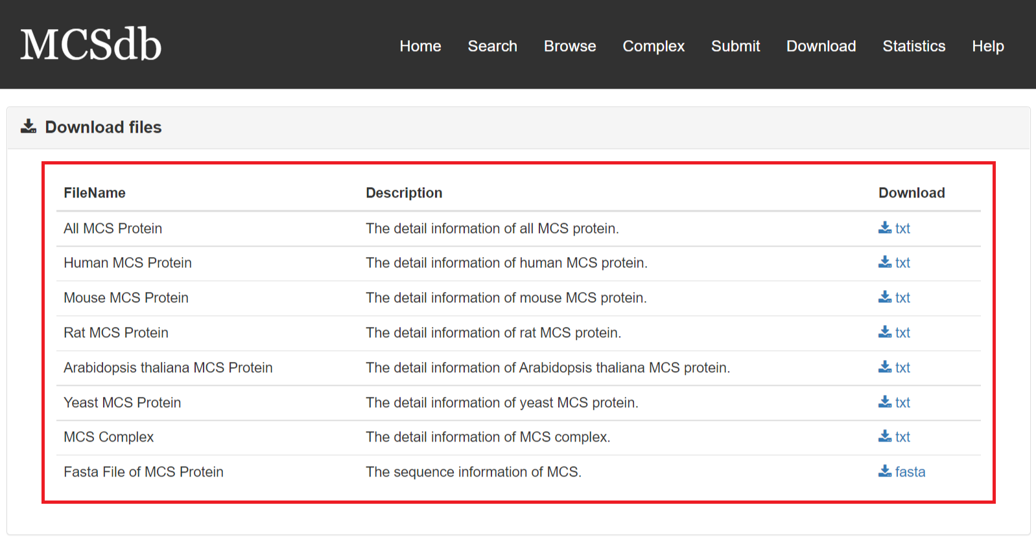

**Fig 7-1. Download page**